KEY Forensics Unit 1 Review

1. What is Locard’s Exchange Principle? When 2 people/objects come into contact with each other, a cross transfer of evidence occurs.

2. What is the world’s largest forensic laboratory? FBI’s National Laboratory (The oldest is the Los Angeles Police Department.)

3. What is an observation? What is perception? An observation is what a person perceives using their senses. A perception is an interpretation of information received from the senses.

4. What factors may influence eyewitness accounts of an event? Level of interest, stress, concentration, amount and kind of distractions, prejudices, personal beliefs, and motives

5. What important principle was established in the case of Frye v. United States? In order to be admitted as evidence at trial, the questioned procedure, technique, or principles must be generally accepted by a meaningful segment of the relevant scientific community.

6. What are the Federal Rules of Evidence? A witness may qualify as an expert by knowledge, skill, experience, training, or education may offer expert testimony if 1. There are sufficient facts or data., 2. The testimony is the product of reliable principles and methods, and 3. The expert witness has applied those principles.methods to the facts of the case.

7. How did the court’s ruling in the case of Daubert v Merrell Dow Pharmaceuticals, Inc. affect the admissibility of scientific evidence in federal courts? 1. The technique/theory can be tested. 2. The technique/theory has been subject to peer review and publication. 3. The potential rate of error is known. 4. There exists a set of standards that are maintained. 5. There is widespread scientific acceptance.

8. What is physical evidence? Any object that can establish that a crime has been committed or can link a crime to its victim or its perpetrator.

9. What is the first step in crime-scene investigation? Secure and isolate the scene. Why is this critical? So that evidence is preserved and not lost.

10. What is the main objective in collecting and packaging physical evidence? To preserve evidence.

11. Why is it important to package items of physical evidence in separate containers? To prevent cross-contamination

12. What is a paper bindle (aka a druggist fold) and why is it used? To contain small pieces of evidence.
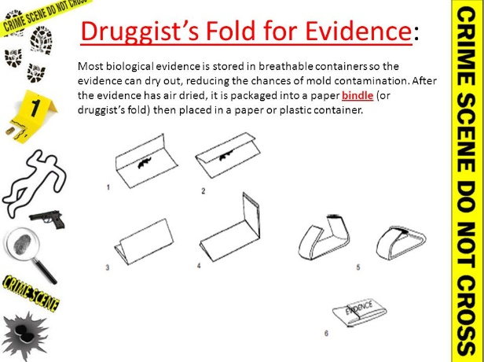

13. Define chain of custody and explain why maintaining a proper chain of custody is important. Chain of custody is a list of all the people who came into possession of an item of evidence. It is important to ensure the evidence is properly and responsibly handled.

14. What is a standard/reference sample and why is it important to the criminalist? Physical evidence whose origin is known such as blood or hair from a suspect or victim that can be compared to crime scene evidence

15. Distinguish between circumstantial evidence and direct evidence? Circumstantial evidence is indirect evidence used to imply a fact and direct evidence is evidence that proves an alleged fact

16. How does individual evidence differ from class evidence? Individual evidence identifies a particular person or thing while class evidence connects it to a group

17. What information must be included in any notes taken at the crime scene? The case number, item inventory number, description of the evidence, name of suspect, name of victim, date and time of recovery, signature of person recovering evidence and signatures of any witnesses to the recovery of the evidence

18. What is a rough sketch and what information must it accurately reflect? A sketch drawn of the crime scene that contains accurate depictions of the dimensions of the scene and shows the location of all objects having a bearing on the case

19. How does a finished sketch differ from a rough sketch? A finished sketch is drawn neatly and to scale.

20. How is comparison different from identification? A comparison is the process of determining if two or more objects has a common origin. An identification is the process of determining a substance’s physical or chemical identity.

21. What are natural variations and how do they affect evidence? Natural variations are normal slight differences among materials, for example hair pulled from the same head can have different colors. The forensic scientist must determine the limit of natural variations they will work within when comparing two pieces of evidence.

22. An investigator at a murder scene notes signs of a prolonged struggle between the attacker and the victim. Name at least three types of physical evidence for which the investigator would likely collect standard/reference samples and explain why he or she would collect them. Hair, fibers, blood, body fluids (spit) – to compare to evidence collected at the scene.

23. How was the crime scene and evidence mishandled in the JonBenet Ramsey case? The police did not isolate the witnesses, people were allowed to walk through the crime scene, proper statements were not taken from the parents, witnesses were asked to help search the house, and the body of the deceased was moved by the father.

