Unit 3: Medicolegal Death Test Review

Death: Meaning, Manner, Mechanism, Cause, and Time
- What is death? What is autolysis?
- Fill in the blanks.
 | Manner | Mechanism | Cause
Definition
Example
- Livor Mortis (Lividity)
  - What is livor mortis (lividity)?
  - When does it start after death?
  - When does it become permanent?
  - What can livor mortis reveal about the body in an investigation?
- Rigor Mortis
Progression of Rigor Mortis
Time After Death | Event | Appearance | Circumstances
2 - 6 hours
12 hours
18 - 36 hours
36 - 48 hours

Factors Affecting Rigor Mortis
Factor | Event | Effect | Circumstances
Temperature
Activity Before Death
Body Weight

- Algor Mortis
  - What is it?
  - How to calculate time of death:
    - Subtract the body temperature from 37°C.
    - Divide the answer by .78 °C/hr.
      - If the answer is 12 or less, this is the time of death. Stop here.
      - If the answer is more than 12, do the following:
        - Take your answer from (i) and subtract 9.36°C.
        - Divide the answer by .39°C/hr. Add this answer to 12 hours and this is your time of death.
  - Practice
    - A body was found with an internal temperature of 19°C. Estimate the time of death.
    - A body was found with an internal temperature of 31°C. Estimate the time of death.
  - Describe how the time of death can be affected in the following situations.
    - It’s really cold.
    - It’s really hot.
    - The body is obese.
    - The body was found in a river.
    - The body was found wrapped in a heavy comforter.
- Stomach and Intestinal Contents
  - How long ago did death occur if there are still undigested food in the stomach?
  - How long ago did death occur if food is found in the small intestine?
  - How long ago did death occur if food is found in the large intestine?
- Eye Changes After Death
  - How long after death does the thin film cover the eye if the eye is open at death?
  - How long after death does the thin film cover the eye if the eye is closed at death?
- Stages of Decomposition of a Body
Stage | What happens during decomposition
Initial Decay
Putrefaction
Black Putrefaction
Butyric Fermentation
Dry Decay
- Insects
  - What is the progression of blowflies through a body?
Forensic Anthropology (Bones)
- How do bones develop?
- What are 3 ways that bones connect?
- How do bones age?
- How many bones does an infant have? How many does an adult have?
- How to distinguish male from female bones:
  - Skull

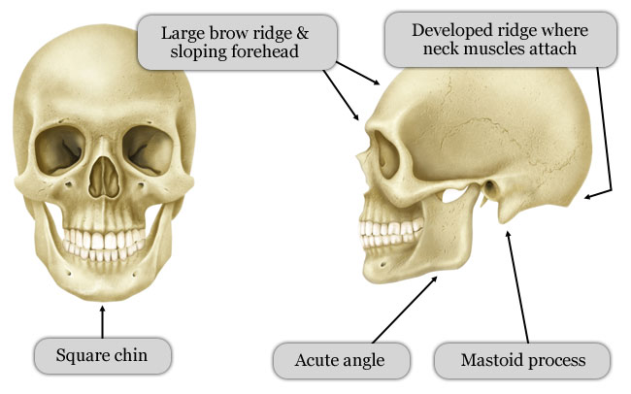
Female Skull
Male Skull

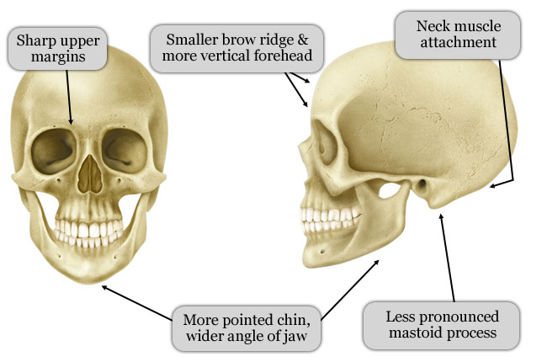

  - Pelvis
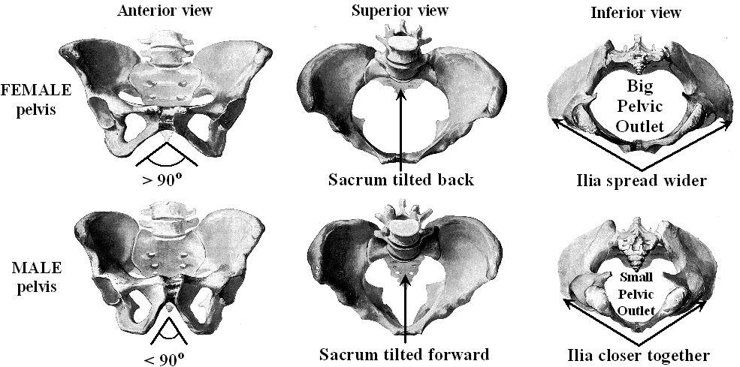

  - Thigh Bone
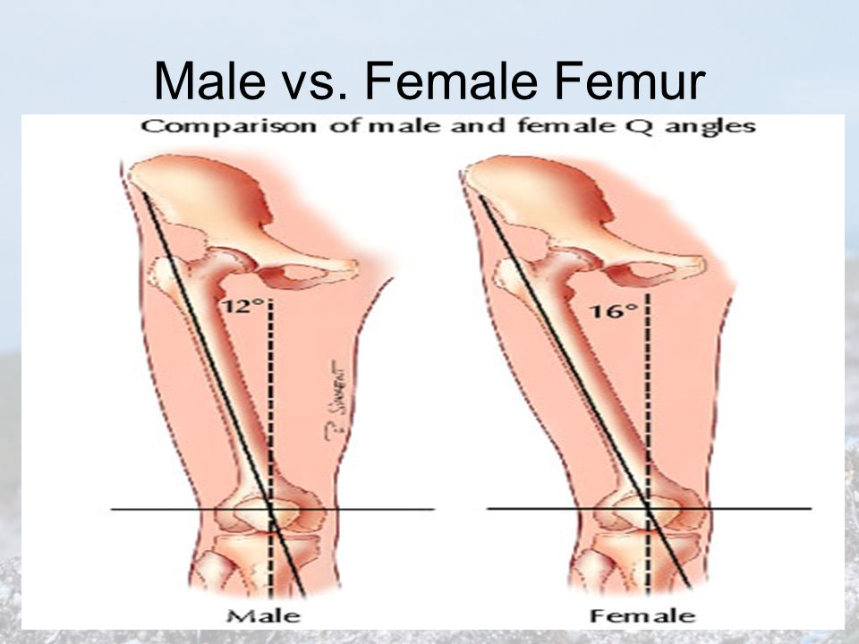
- How to determine the age of bones
  - Suture Marks in the Skull
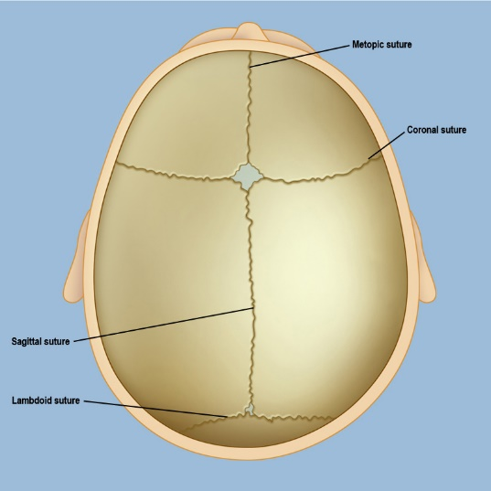
- Coronal suture closes at age 50.
- Lambdoidal suture begins closing at 21, accelerates at age 26, and closes at 30.
  - Cartilaginous Lines (Growth Plates)
Babies are born with more than 450 bones. Adults have 206 bones.
As cartilage is slowly replaced with bone, the plate slowly disappears.

  - Estimation of Age Using Bones – Fill in the chart
Region | Bone | Age
Arm | humerus bone (head fused) | 4 – 6 years
 | humerus bones (head fused to shaft) | 18 – 20 years
Leg | femur (greater trochanter 1st appears) | 4 years
 | femur (less trochanter 1st appears) | 13 – 14 years
 | femur (head fused to shaft) | 16 – 18 years
 | condyles join shaft | 20 years
Shoulder | clavicle & sternum close | 18 – 24 years
Pelvis | pubis, ischium are almost united | 7 – 8 years
 | ileum, ischium, & pubic bones fully ossified | 20 – 25 years
 | all segments of sacrum united | 25 – 30 years
Skull | lambdoidal suture closed | Begins at 21 years, closes at 30 years
 | sagittal suture closed | 32 years
 | coronal suture closed | 50 years

  - How to Estimate Height
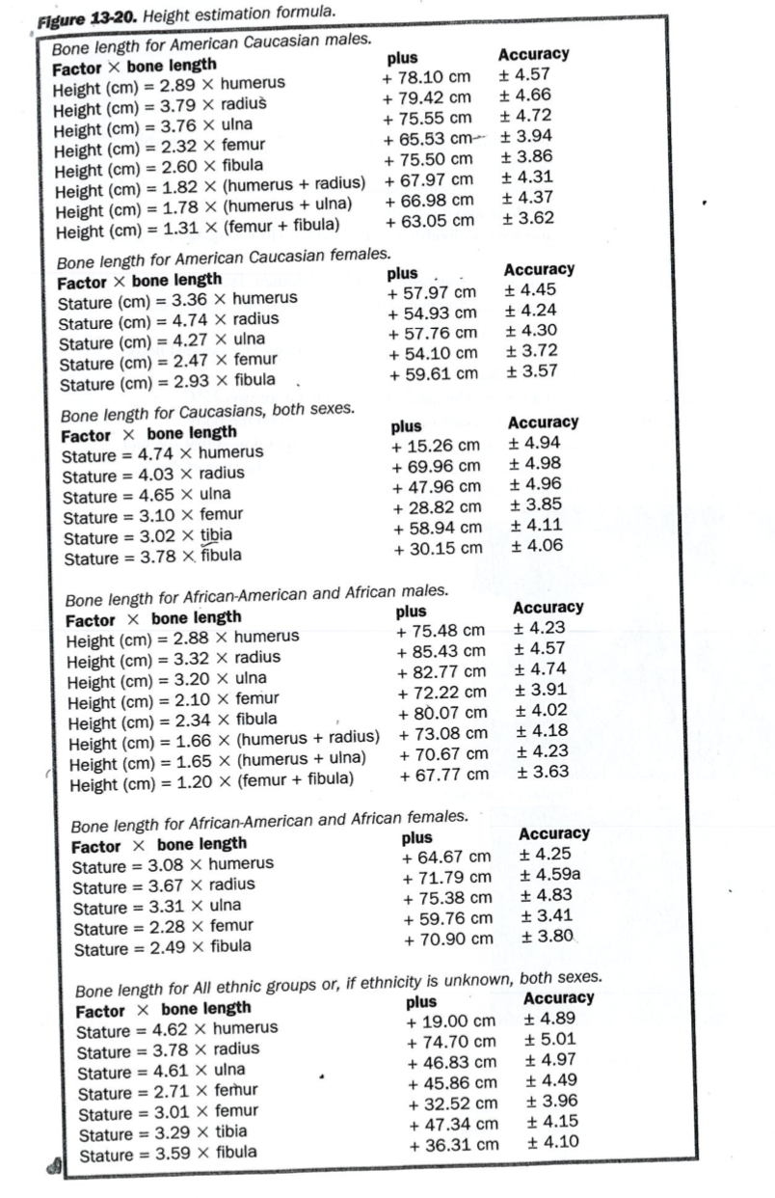
Practice Problems:
- A body was found with lividity on his back, buttocks, and the heels of his feet that turned white when pressed. Estimate how long ago he died?
- A body was found to have permanent lividity after being found outside on a warm night. He had rigor everywhere except in his head. How long ago did he die?
- A body was found in an abandoned house with no lividity or rigor mortis. How long ago did she die?
- A body was found in an alley. Permanent lividity was present on her abdomen, face, and upper thighs. She has rigor in her hips and legs and her stomach and small intestine were empty but food was found in her large intestine. How long ago did she die?
- A body was found lying in the grass in the park on a warm night at midnight. Her internal body temperature was 33°C. Calculate the time of death.
- A body was found inside the kitchen of a house. The man’s body temperature was 25°C. Calculate the time of death. Blowfly eggs and larva 1 (instar 1) were found on the body.
- A body of an ill man was found to have a temperature of 36°C. His wife mentioned that she had taken his temperature before going to bed and his fever was 39°C. Calculate the time of death.
- Identify which pelvis is male and which is female? Explain your answers.
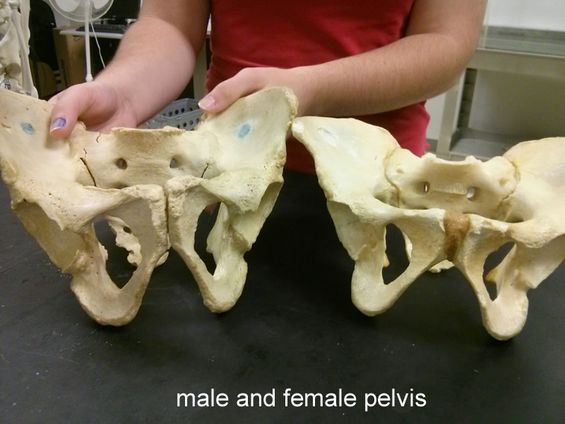
- Identify the male and female skull. Explain your answers.
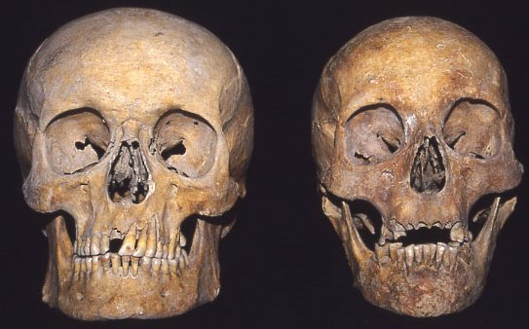

- Estimate the height of these individuals.
  - Caucasian male femur – 50.6cm.
  - African-American female femur – 49.5cm.
  - African-American male humerus – 39.94cm.
  - Caucasian female ulna – 23.4cm

