Unit 2 Remediation Packet

Due: Thursday, 10.4.18
Tutoring Offered: Mondays from 3:40 – 5:00pm or mornings by appointment. Please sign up!
Re-Test Dates: Monday, 10.8.18 or Wednesday, 10.10.18 from 3:40 – 5:00pm

The remediation packet must be completed and checked BEFORE re-testing will occur.

Ionic Bonding

- Which two types of elements can form an ionic bond?
- What is an ionic bond?
- How does a positively charged cation form? How does a negatively charged anion form?
- Why does an ionic bond form?
- Draw electron dot diagrams to show the formation of an ionic bond between the elements provided. You must show the transfer of electrons, the charges formed, and the formula of the resulting ionic compound.
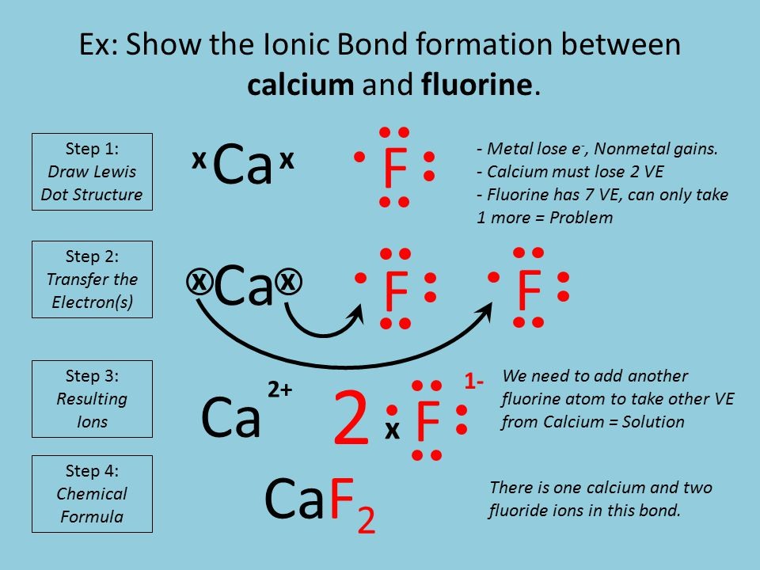

  - Na and S
  - Ca and N
  - Li and P
  - Sn and O

Covalent Bonding – here’s a tutorial if needed https://chemfiesta.org/2015/01/20/drawing-simple-lewis-structures/

- What types of elements are involved in covalent bonds?
- How does a covalent bond form?
- Why does a covalent bond form?
- Draw Lewis structures to show the formation of covalent bonds in these molecules:
  - H₂O
  - CS₂
  - SO₃
  - NF₃
  - SiBr₂H₂

Nomenclature – Names and Formulas – need assistance? Here’s a tutorial.
https://chemfiesta.org/2015/03/23/ionic-and-covalent-compounds/
https://chemfiesta.org/2015/09/18/covalent-compounds-lewis-structures/

- How can you tell from the name that a substance is a(n)…
  - Type I ionic compound?
  - Type II ionic compound?
  - Type III covalent compound?
  - Binary acid?
  - Oxyacid?
- How can you tell from the formula that a substance is a(n)…
  - Type I ionic compound?
  - Type II ionic compound?
  - Type III covalent compound?
  - Binary acid?
  - Oxyacid?
- What is the difference between a binary compound and a tertiary compound?
  - Which types of compounds do you criss-cross charges?
  - Which type of compound do you never criss-cross because it does NOT have any charges?
- Identify if the following compounds are Type I, Type II, Type III, Binary Acid, or Oxyacid?
  - Chromium (III) sulfide
  - Carbon dioxide
  - Acetic acid
  - Calcium nitrite
  - Iron (II) hydroxide
  - Sulfur trioxide
  - Hydrosulfuric acid
  - Tetracarbon decahydride
  - Aluminum fluoride
  - MgSO₃
  - P₂O₅
  - H₂C₂O₄
  - C₃H₇
  - Cr(ClO₂)₃
  - HF
  - NO₃
  - Ag₃P
  - Li₂CrO₄
- Write the formula for the following compounds.
  - Hydrophosphoric acid
  - Manganese (II) cyanide
  - Beryllium iodide
  - Dinitrogen pentasulfide
  - Nitrous acid
  - Copper (I) dichromate
  - Aluminum sulfate
  - Dicarbon hexachloride
  - carbon monoxide
  - carbonic acid
- Write the name for the following compounds.
  - H₂O
  - Na₂S
  - C₂H₆
  - WPO₄
  - H₃N
  - C₄H₉
  - HNO₂
  - IF₇
  - Au(C₂H₃O₂)₃
  - NaOH

