KEY Forensics Unit 1 Review

1. What is Locard’s Exchange Principle? When 2 people/objects come into contact with each other, a cross transfer of evidence occurs.

2. What is the world’s largest forensic laboratory? FBI’s National Laboratory (The oldest is the Los Angeles Police Department.)

3. What is an observation? What is perception? An observation is what a person perceives using their senses. A perception is an interpretation of information received from the senses.

4. What factors may influence eyewitness accounts of an event? Level of interest, stress, concentration, amount and kind of distractions, prejudices, personal beliefs, and motives

5. What are ways to improve observational skills? Pay attention to all the details, try not to filter out information. Do not look for patters or to interpret what is observed, and record everything because memories are faulty.

6. What important principle was established in the case of Frye v. United States? In order to be admitted as evidence at trial, the questioned procedure, technique, or principles must be generally accepted by a meaningful segment of the relevant scientific community.

7. How did the court’s ruling in the case of Daubert v Merrell Dow Pharmaceuticals, Inc. affect the admissibility of scientific evidence in federal courts? 1. The technique/theory can be tested. 2. The technique/theory has been subject to peer review and publication. 3. The potential rate of error is known. 4. There exists a set of standards that are maintained. 5. There is widespread scientific acceptance.

8. What is physical evidence? Any object that can establish that a crime has been committed or can link a crime to its victim or its perpetrator.

9. What is the first step in crime-scene investigation? Secure and isolate the scene. Why is this critical? So that evidence is preserved and not lost.

10. What is the main objective in collecting and packaging physical evidence? To preserve evidence.

11. Why is it important to package items of physical evidence in separate containers? To prevent cross-contamination

12. What is a paper bindle (aka a druggist fold) and why is it used? To contain small pieces of evidence.
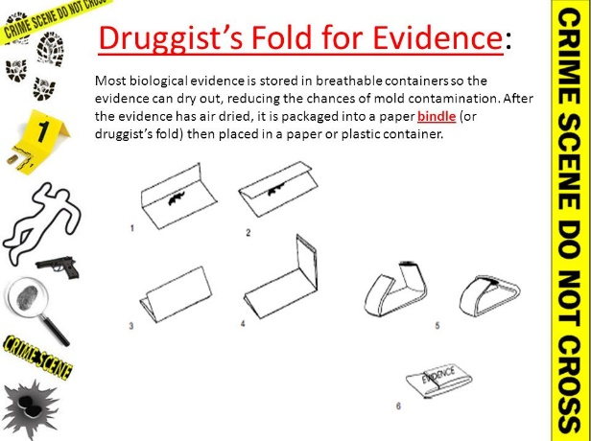

13. Define chain of custody and explain why maintaining a proper chain of custody is important. Chain of custody is a list of all the people who came into possession of an item of evidence. It is important to ensure the evidence is properly and responsibly handled.

14. What is a standard/reference sample and why is it important to the criminalist? Physical evidence whose origin is known such as blood or hair from a suspect or victim that can be compared to crime scene evidence

15. Distinguish between circumstantial evidence and direct evidence? Circumstantial evidence is indirect evidence used to imply a fact and direct evidence is evidence that proves an alleged fact

16. How does individual evidence differ from class evidence? Individual evidence identifies a particular person or thing while class evidence connects it to a group

17. What is a standard/reference sample and why is it important to the criminalist? See #14

18. What information must be included in any notes taken at the crime scene? The case number, item inventory number, description of the evidence, name of suspect, name of victim, date and time of recovery, signature of person recovering evidence and signatures of any witnesses to the recovery of the evidence

19. What is a rough sketch and what information must it accurately reflect? A sketch drawn of the crime scene that contains accurate depictions of the dimensions of the scene and shows the location of all objects having a bearing on the case

20. An investigator at a murder scene notes signs of a prolonged struggle between the attacker and the victim. Name at least three types of physical evidence for which the investigator would likely collect standard/reference samples and explain why he or she would collect them. Hair, fibers, blood, body fluids (spit) – to compare to evidence collected at the scene.

21. What is the oldest forensic science lab in the United States? Los Angeles Police department, created in 1923.

22. What is included in a rough sketch? Contains an accurate depictions of the dimensions of the scene and shows the location of all objects having a bearing on the case. Objects are measured from 2 adjacent fixed points in the room. A compass depicting north is also on the rough sketch.
A finished sketch? Precise rendering of the crime scene, usually drawn to scale.

23. What do crime scene notes include? A detailed written description of the scene with the location of items of physical evidence recovered, time items was recovered, by whom, and how it was packaged and marked, and the manner in which it was collected.

24. What are the full names for these crime scene databases: IAFIS, NIBIN, CODIS, PDQ, SICAR, and NamUs?
IAFIS – Integrated Automated Fingerprint Identification System
NIBIN – National Integrated Ballistics Information Network
CODIS – COmbined DNA Index System
PDQ – International Forensic Paint Database Query
SICAR – Shoeprint Image Capture & Retrieval
NamUs – National Missing and Unidentified Persons System

