Scientific Method 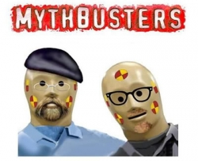
Name
Period 1 2 3
Myth # 1
Observation: What is the myth?

Hypothesis: What do they think is happening before experimenting?

Experiment: Detailed plan to experiment

Data/Results: What happened?

Conclusion: Confirmed (true), plausible (might be true under certain conditions), or busted (false)

Myth # 2
Observation: What is the myth?

Hypothesis: What do they think is happening before experimenting?

Experiment: Detailed plan to experiment

Data/Results: What happened?

Conclusion: Confirmed (true), plausible (might be true under certain conditions), or busted (false)

