J.J. Thomson

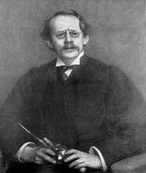

A short history of his life:﻿﻿﻿
J.J. Thomson (Joseph John Thomson) was born in Cheetham Hill (a suburb of Manchester) on December 18, 1856. He is not still alive today. He went to Owens College in Manchester, in 1870. In 1876, he entered Trinity College in Cambridge as a minor scholar. Thomson studied mathematics and physics. He remained a member of Trinity College for the rest of his life and became a Lecturer in 1883 and a Master in 1918. In 1890, he married Rose Elisabeth and they had one son, (now Sir George Paget Thomson) and one daughter. J.J. Thomson died on August 30, 1940.
Early interests in atoms:
﻿
It was evident Thomson was interested in atomic structure, which was evident in his book Treatise on the Motion of Vortex Rings which he won the Adams Prize for in 1884. Joseph returned to America in 1904 and delivered six lectures about electricity and matter at Yale University. He later discovered a method used to separate different kinds of atoms and molecules from the use of positive rays. This idea was developed by Aston, Dempster, and a few other people. Thomson was elected Fellow of the Royal Society in 1884. He served as President from 1916-1920. Also, he received the Royal Medal and Hughes Medal in 1894 and 1902 and many other medals. Thomson studied in Great Britain and also in America.
Discoveries:
J.J. Thomson discovered electrons and noticed that an atom can be divided. Also, he concluded atoms are made of positive cores and negatively charged particles within it. He developed the Plum Pudding Model before the atomic nucleus was discovered. This model shows that the electrons are surrounded by a "pudding" of positive charges to balance the negative charges. Today, J.J. Thomson's discoveries have helped people to have a better understanding of the atom and its generic makeup.

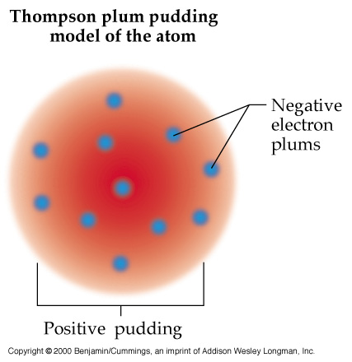
﻿

Sources!!!
MLA style: "J.J. Thomson - Biography". Nobelprize.org. 19 Nov 2010 http://nobelprize.org/nobel_prizes/physics/laureates/1906/thomson-bio.html
"J.j. Thomson Atomic Model | Tutorvista.com." Tutorvista.com - Online Tutoring, Homework Help for Math, Science, English from Best Online Tutor. Web. 22 Nov. 2010. <http://www.tutorvista.com/chemistry/jj-thomson-atomic-model>.
IMAGES:
http://www.kutl.kyushu-u.ac.jp/seminar/MicroWorld1_E/Part2_E/P24_E/Thomson_model_E.jpg
http://reich-chemistry.wikispaces.com/file/view/jj_thomson.jpg/177646183/jj_thomson.jpg
http://reich-chemistry.wikispaces.com/file/view/plum.jpg/147037063/plum.jpg

J.J. Thomson's Cathode Ray Tube (CRT): Definition, Experiment & Diagram
J. J. Thomson's cathode ray tube experiments led to a very important scientific discovery, the electron. In this lesson learn what a cathode ray tube is, and how J. J. Thomson made his discovery.

Cathode Ray Tubes in Your Home
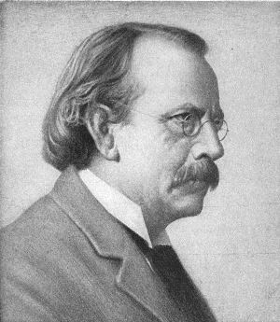
Portrait of J. J. Thomson
You might have used a cathode ray tube even if you've never even heard of it until reading this lesson. Before LCD and Plasma TVs became commonplace, most people used bulkier cathode ray tube (CRT) televisions. The CRT in a television is used to display images on your screen. However, cathode ray tubes have been used for more than entertainment. It was cathode ray tubes that allowed the English physicistJ.J. Thomson to discover the existence of electrons in 1897.

How Cathode Ray Tubes Work
Before we see how J.J. Thomson used the cathode ray tube to discover the electron, we need to know how a cathode ray tube works. We'll look at a basic CRT like what J.J. Thomson would've used, as seen in the diagram below.
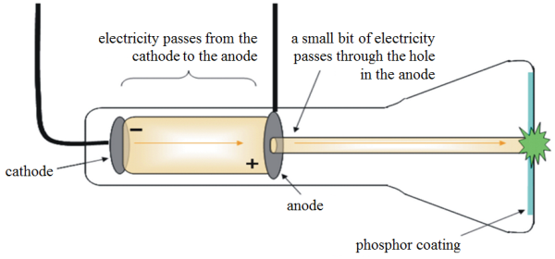
Cathode Ray Tube Diagram
The CRT consists of several elements starting with a tube that's vacuum sealed to keep air out of it. On one side of the inside of the tube there's a cathode and an anode. The cathode is a negatively-charged conductor, and the anode is a positively-charged conductor. Electrons, which have a negative charge, flow off the cathode and are attracted towards the anode. A small hole in the anode allows some electrons to pass through it, creating a beam of electrons. On the opposite side of the tube is a coating that glows when struck by the electrons. This allowed J. J. Thomson to see where the electron beam was hitting.
Of course, before his experiment, we didn't know electrons existed. So no one was calling it an electron beam. Instead, what flowed off the cathode toward the anode were called 'cathode rays.' Hence the name cathode ray tube.

The Three Experiments
J.J. Thomson's discovery of electrons didn't happen all at once. Instead, it was a result that was slowly built towards over the course of three different experiments. Before Thomson's experiments, it had already been discovered that the cathode rays deposit an electric charge. This was done by putting an electrometer at the opposite end from the cathode and anode. When the cathode rays hit the electrometer, it measured an electric charge.
The first experiment was done in order to see if the charge was separate from the cathode rays. Thomson used a magnet to bend the cathode rays away from the electrometers. When he did this, he discovered that the electrometers stopped measuring electric charge. From this he deduced that the electric charge and the cathode rays must be combined together and not separate entities.
Next, J.J. Thomson set out to determine if the charge carried by the cathode rays was negative or positive. To do this he would use an electric field. He put a negatively charged metal plate on one side of the cathode rays let out past the anode, and a positively charged metal plate on the other side. Instead of an electrometer at one end of the CRT he now had a fluorescent coating that would glow where the cathode ray hit it. When the charged metal plates were introduced he found that the cathode rays bent toward the positive plate and away from the negative plate. This showed that the charge carried by the cathode rays was negative.
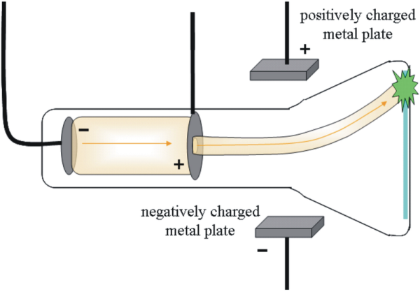
Diagram of the 2nd Experiment of J. J. Thomson

