Heterogeneous Mixture Separation Lab 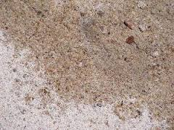

Problem: There is a mixture of sand, iron filings, salt and rock salt. Your group must figure out which physical properties to use in order to successfully separate all three components. You will be given the equipment below and must first develop a procedure (that must be approved) before starting your separation process. Make sure your group is thinking about the properties of each individual substance that are different from the other substances. At each stage of the separation process, you MUST write observations. Be very specific and detailed!
