Unit 3 – Atomic Theory and the Periodic Table
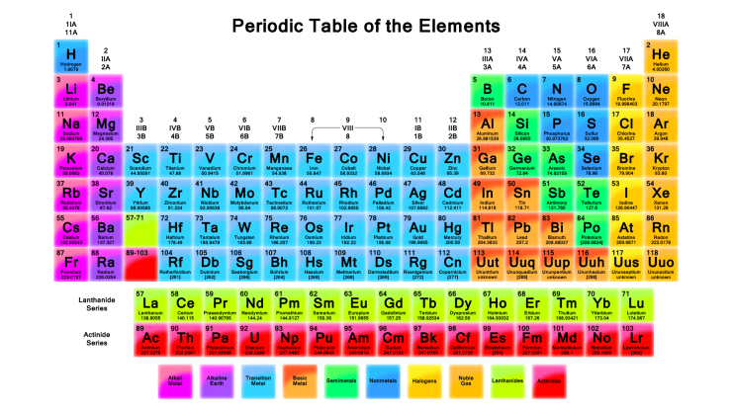

Georgia Performance Standards
SC3: Students will use the modern atomic theory to explain the characteristics of atoms.

- Discriminate between the relative size, charge, and position of protons, neutrons, and electrons in the atom.
- Use the orbital configuration of neutral atoms to explain its effect on the atom’s chemical properties.
- Explain the relationship of the proton number to the element’s identity.
- Explain the relationship of isotopes to the relative abundance of atoms of a particular element.
- Relate light emission and the movement of electrons to element identification.

SC4: Students will use the organization of the Periodic Table to predict properties of elements.
- Use the Periodic Table to predict periodic trends including atomic radii, ionic radii, ionization energy, and electronegativity of various elements.
- Compare and contrast trends in the chemical and physical properties of elements and their placement on the Periodic Table
 | Assignments |  |  | Assignments
1 | CW 1 - Atomic Structure |  | 5 | Project - Atomic Theory
2 | CW 2 - Electron Configurations |  | 6 | Lab: Flame Tests
3 | CW 3 - Electrons and Light |  | 7 | HW 1 - Atomic Structure & Electrons
4 | CW 4 - Periodic Table & Trends |  | 8 | HW 2 - Periodic Table & Trends

