Timeline Assignment
Development of Atomic Theory
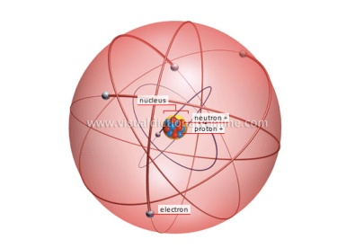
Directions:
Using your textbook and the internet, research the following people and events. Create a chronological timeline of the people and events. Your timeline must include more than the date(s) and a name or event; you must explain, in your own words, what happened. Pictures or drawings are always nice.

People/ Events
Democritus discovery of electrons
Aristotle discovery of protons
Alchemists discovery of neutrons
John Dalton discovery of nucleus
Dmitri Mendeleev creation of the Periodic Table
J.J. Thomson Dalton’s Atomic Theory
Sir William Crookes Cathode Ray Experiment
Ernest Rutherford Plum Pudding Model
H.G.J. Moseley Gold Foil Experiment
James Chadwick Chadwick- Rutherford Model
Neils Bohr Planetary Model
Erwin Schrödinger Wave-Mechanical Model

